**Group name:** KEYY Maker

**Team Members:**

1. Yash Chavda
2. Yash Vira
3. Md Endan Mollick
4. Krish Savla

**Project:** Safe Chain

**Description:**

A Decentralized Application for Supply Chain Management is being developed in this project. Our Supply Chain Management is based on blockchain technology. To deploy our smart contracts, we use the polygon Mumbai test net.

Frontend: It allows users to enter product details such as the name of the product, the name of the manufacturer, the required temperature, humidity, location, and destination.

Using the status tab, one can find real-time data about a particular product and track the product.

**Implementation:**

Frontend

Frontend is build using HTML,CSS,JS

Webpages build to get user input.

Backend:

In Backend we have used Solidity.

Solidity conttract is compiled on Remix IDE

Deployed on **POLYGON** mumbai testnet

Connected to Frontend using ABI.json and Web3.js

After that Contract is deployed on Polygon mumbai testnet.

From there we get Contract Address and deployed bytecode.

**Screenshots:**

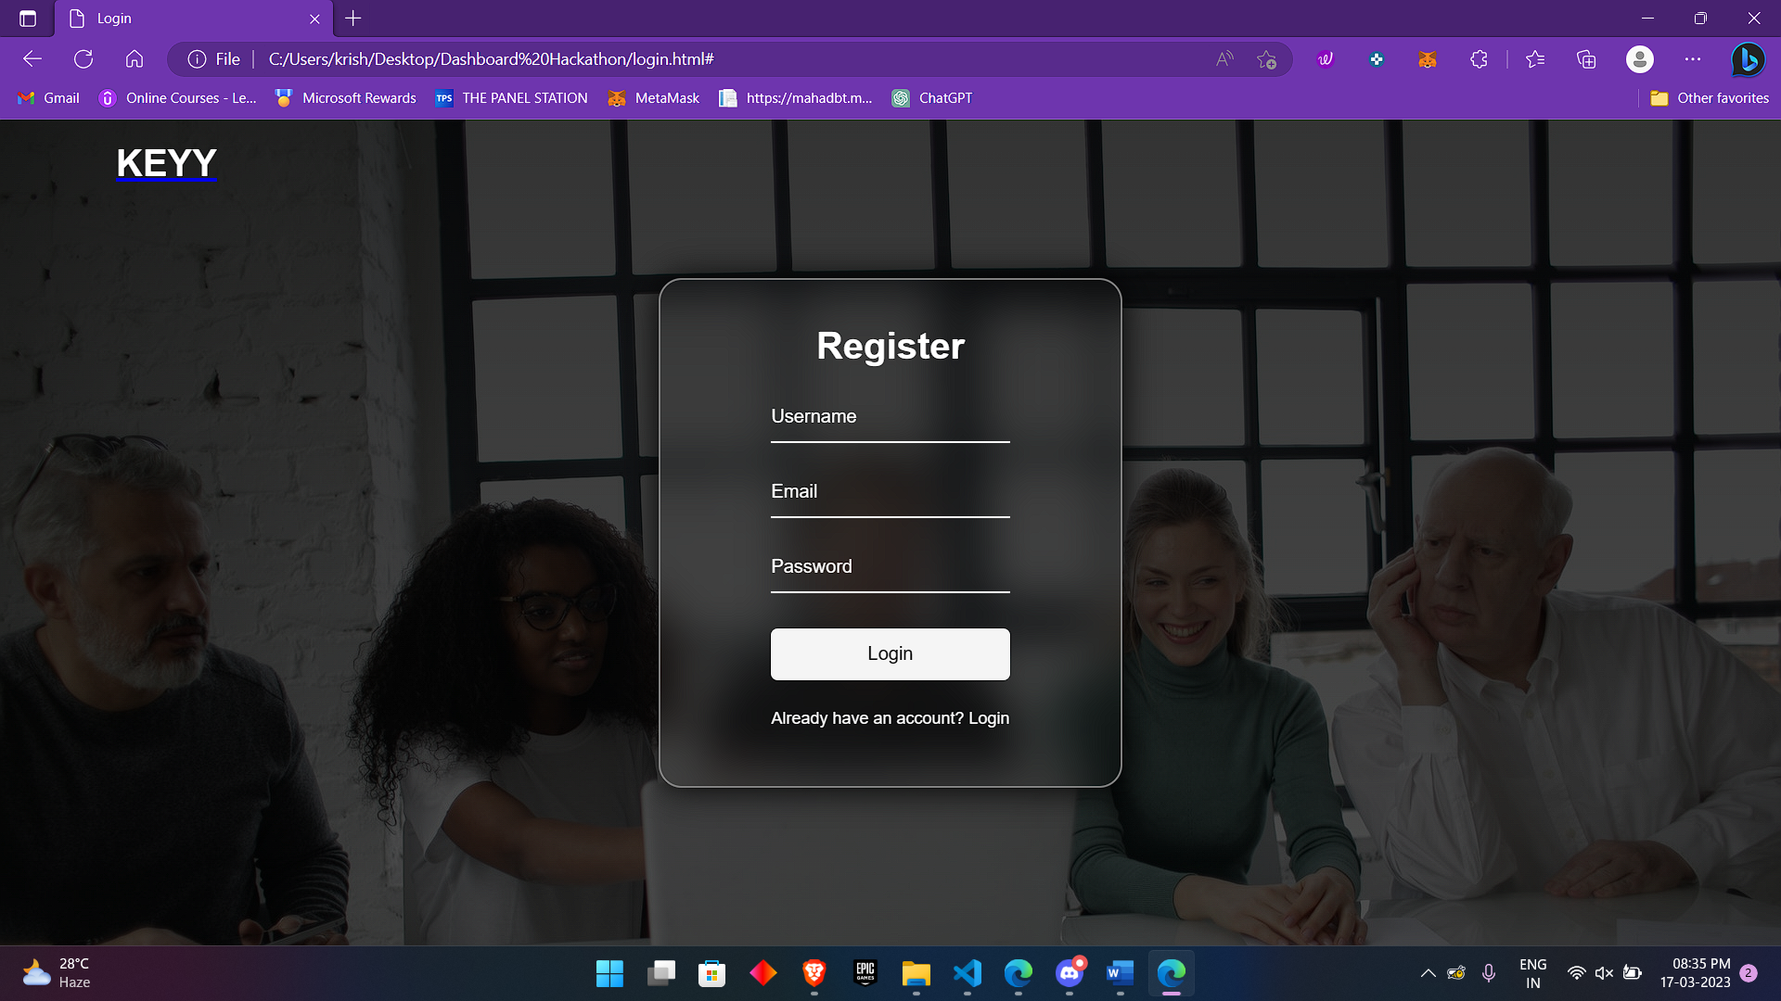

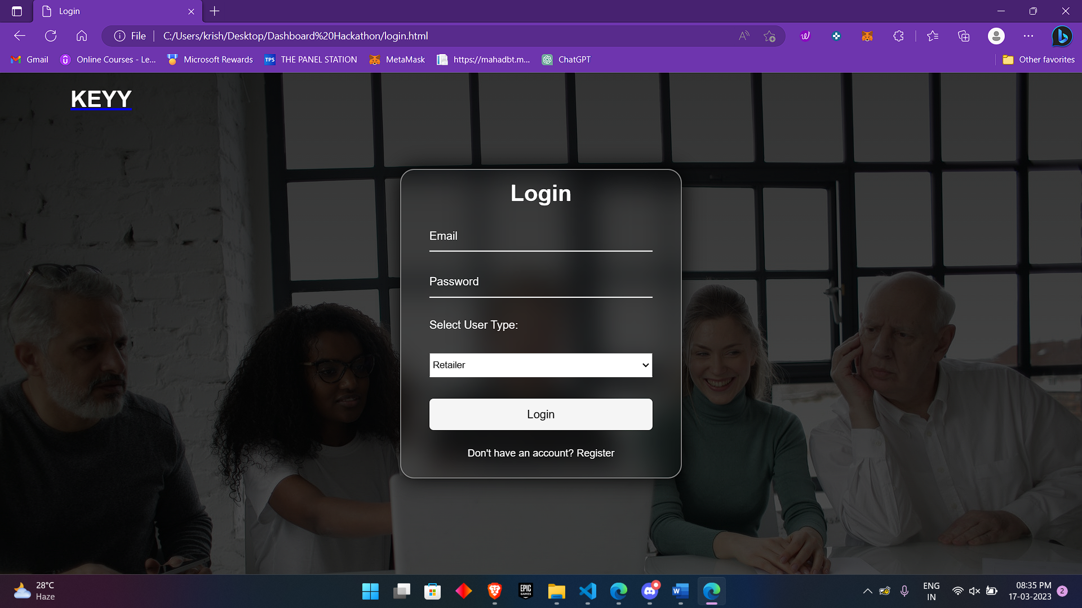

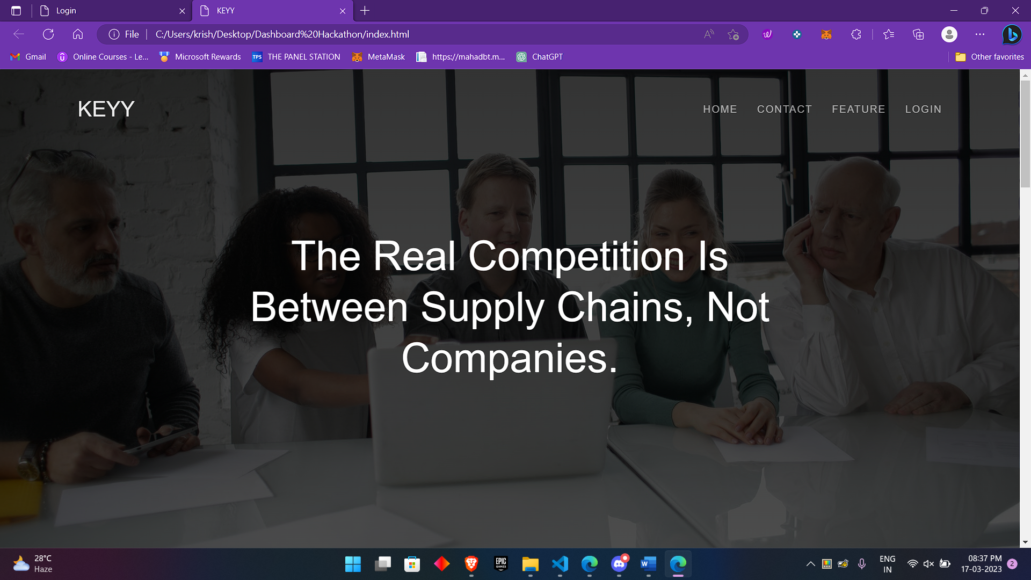

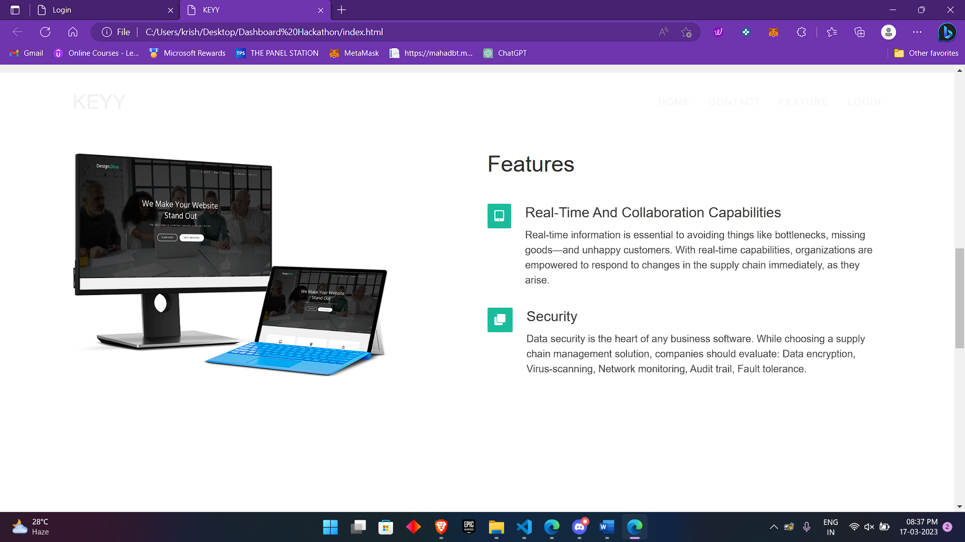

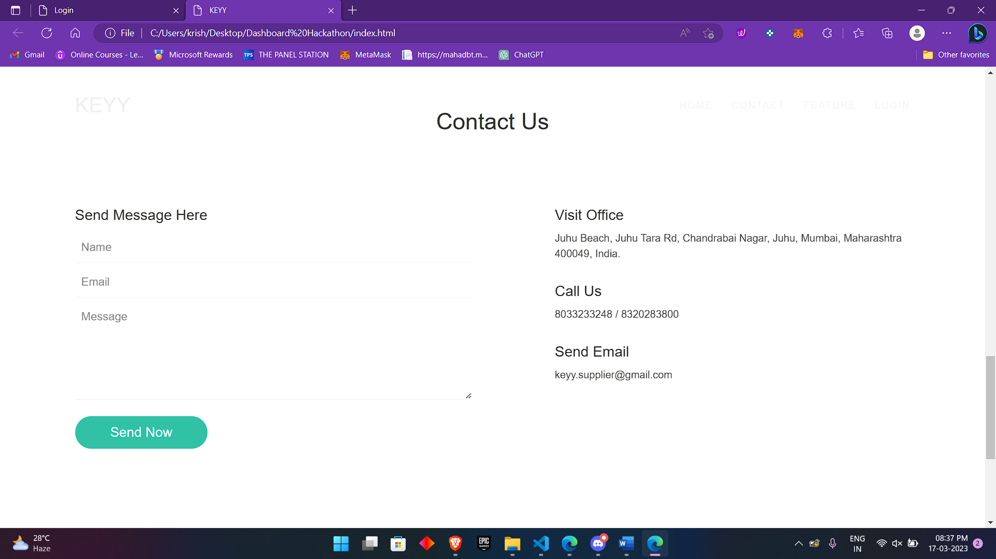

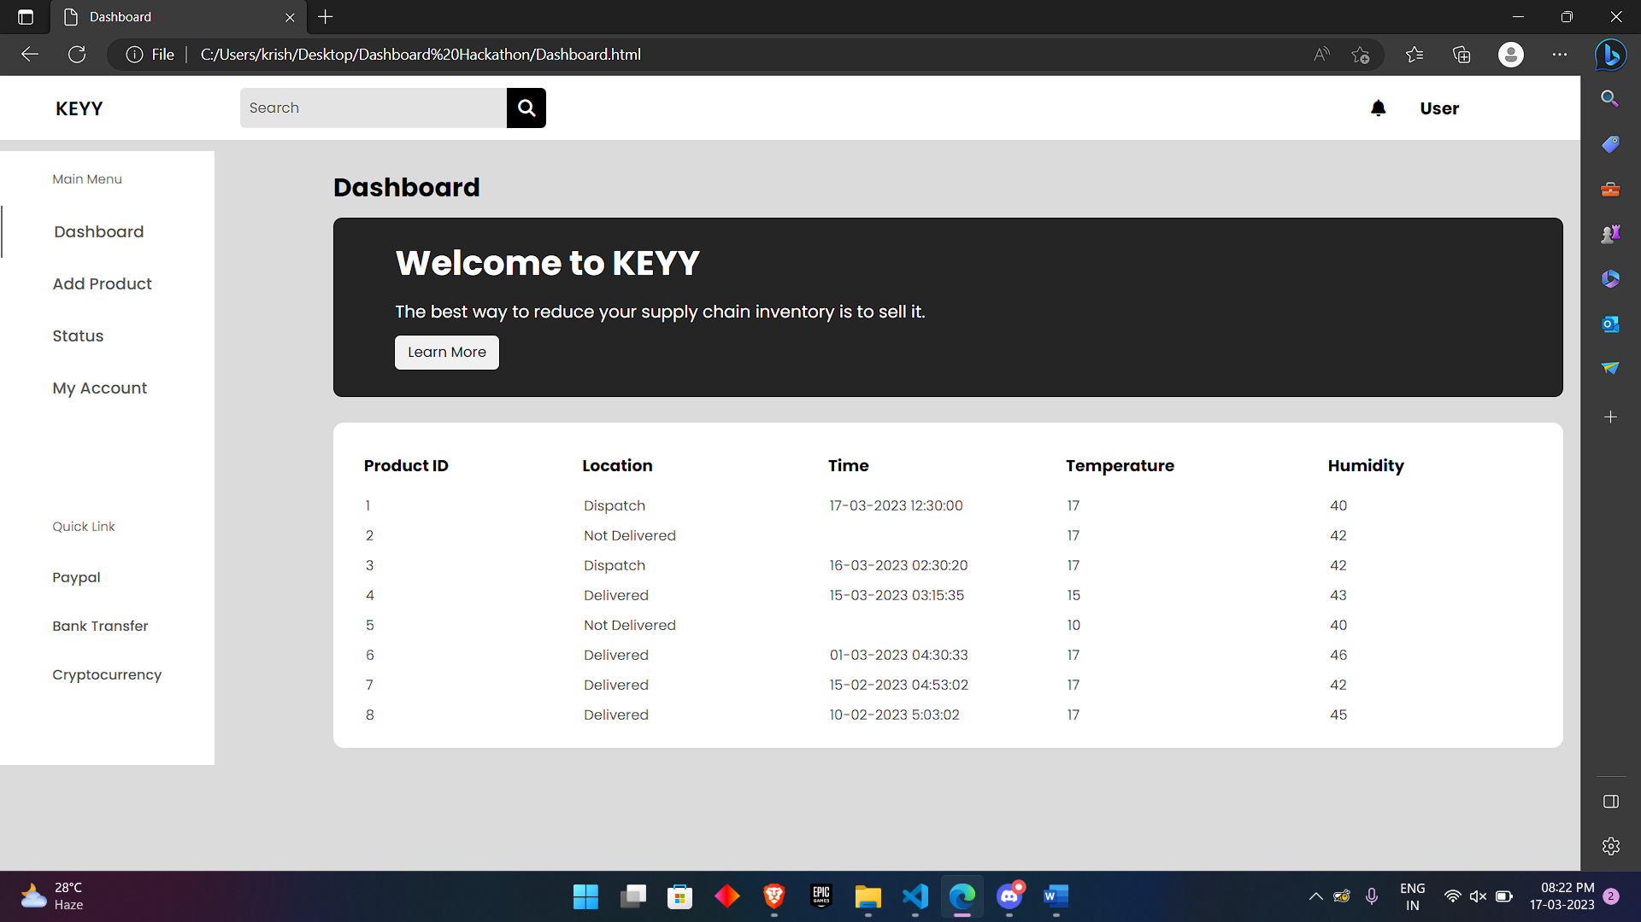

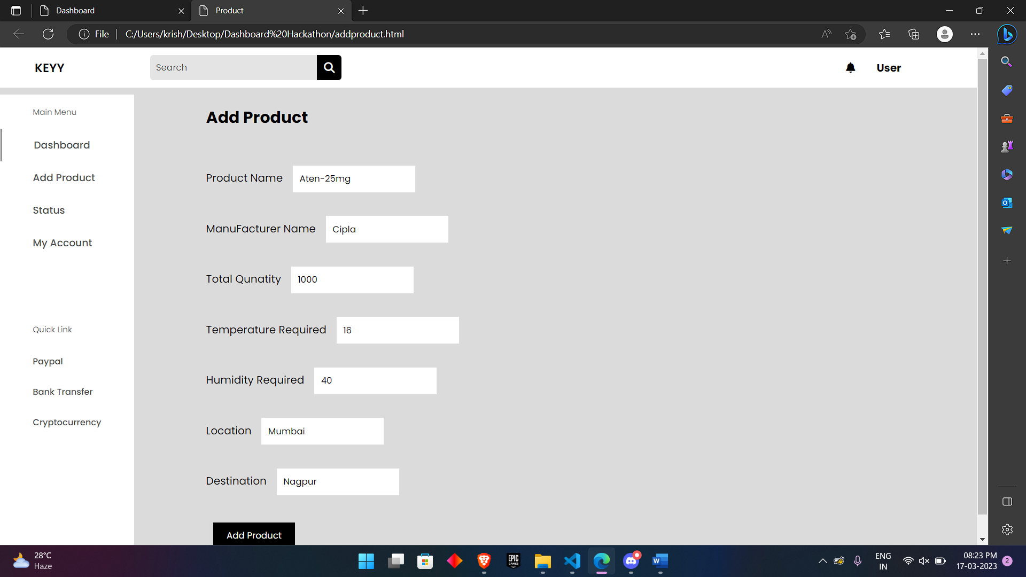

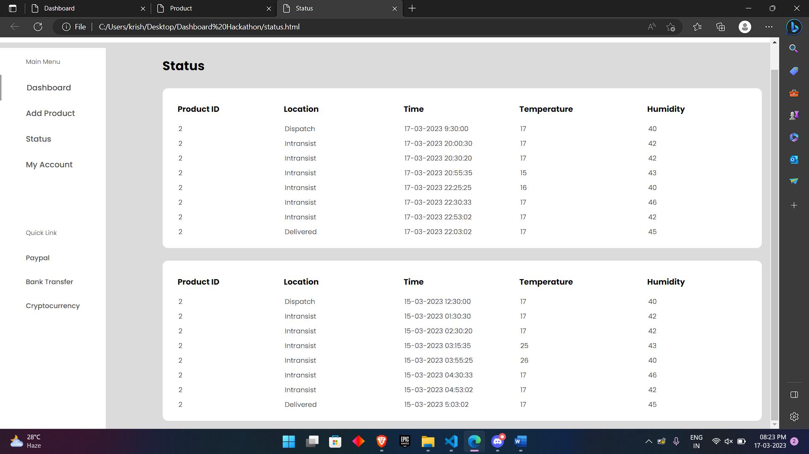

**Folder Structure:**

Backend

|---SupplyChain.sol

|---ABI.json

Frontend

|---dashboard.html

|---Addproduct.js

|---addproduct.html

|---status.html

|---style.css

Login

|---login.html

|---index.html

|---css

|---main.css

|---style.css

**Folder Structure Explanation:**

Backend: Backend consists of Solidity contract. Solidity Contract consists two functions Product Data and Live Data of the Medicines being transported. In Product data function, there are 7 variables Name, manufacturer, required temperature, required humidity, Source, Destination & total quantity. After Solidity contract is compiled on remix ide ABI file and byte code is generated which is stored in json file.

Frontend: This folder contain code for frontend i.e. user interface with the Safe Chain Web app

|--- Addproduct.js : Contain logic for Adding product by manufacturer to be tracked by authorised user

|---dashboard.html: Contain html code to User dashboard where user can see his product history

Login: This folder contains code for login and register for new user to engage to Safe Chain Web app.